DOP: / /2023 DOS: / /2023

**Experiment No: 01**

**Development boards**

**Aim:** Study of various development boards- Arduino Uno and Raspberry Pi, Node MCU

**Hardware Components:**

● Arduino Uno board

● Raspberry Pi board

**Theory:**

**A] Arduino Uno**

**Introduction:**

The Arduino Uno is a microcontroller board based on the ATmega328.

It has 14 digital input/output pins (of which 6 can be used as PWM outputs),

6 analog inputs,

a 16 MHz crystal oscillator,

a USB connection, a power jack, an ICSP header, and a reset button.

It contains everything needed to support the microcontroller; simply connect it to a computer with a USB cable or power it with a AC-to-DC adapter or battery to get started. The Uno differs from all preceding boards in that it does not use the FTDI USB-to-serial driver chip. Instead, it features the Atmega8U2 programmed as a USB-to-serial converter.

"Uno" means one in Italian and is named to mark the upcoming release of Arduino 1.0. The Uno and version 1.0 will be the reference versions of Arduino, moving forward. The Uno is the latest in a series of USB Arduino boards, and the reference model for the Arduino platform; for a comparison with previous versions.

**Power:**

The Arduino Uno can be powered via the USB connection or with an external power supply. The power source is selected automatically. The board can operate on an external supply of 6 to 20 volts. If supplied with less than 7V, however, the 5V pin may supply less than five volts and the board may be unstable. If using more than 12V, the voltage regulator may overheat and damage the board. The recommended range is 7 to 12 volts.

**Memory:**

The Atmega328 has 32 KB of flash memory for storing code (of which 0,5 KB is used for the bootloader); It has also 2 KB of SRAM and 1 KB of EEPROM.

**Communication:**

The Arduino software includes a serial monitor which allows simple textual data to be sent to and from the Arduino board. The RX and TX LEDs on the board will flash when data is being transmitted via the USB-to serial chip and USB connection to the computer.

**Pin Configuration:**

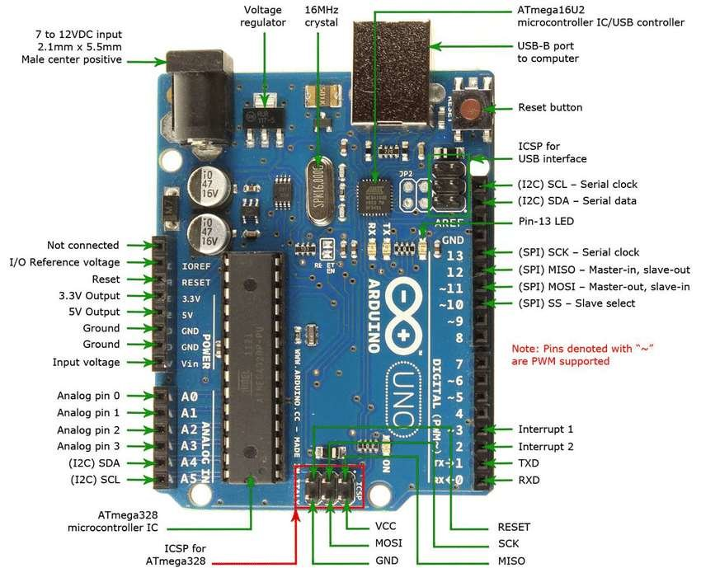

**The power pins are as follows:**

* VIN. The input voltage to the Arduino board when it's using an external power source (as opposed to 5 volts from the USB connection or other regulated power source).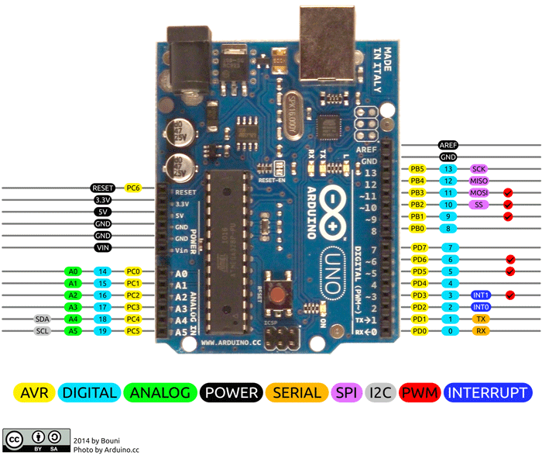You can supply voltage through this pin, or, if supplying voltage via the power jack, access it through this pin.
* 5V. The regulated power supply used to power the microcontroller and other components on the board. This can come either from VIN via an on-board regulator,or be supplied by USB or another regulated 5V supply.
* 3V3. A 3.3 volt supply generated by the on-board regulator. Maximum current draw is 50 mA.

**GND. Ground pins.**

Communication Pins are:

* **Serial:** 0 (RX) and 1 (TX). Used to receive (RX) and transmit (TX) TTL serial data. These pins are connected to the corresponding pins of the ATmega8U2 USB-to-TTL Serial chip
* **External Interrupts:** 2 and 3. These pins can be configured to trigger an interrupt on a low value, a rising or falling edge, or a change in value.
* **PWM:** 3, 5, 6, 9, 10, and 11. Provide 8-bit PWM output with the analogWrite() function
* **SPI:** 10 (SS), 11 (MOSI), 12 (MISO), 13 (SCK). These pins support SPI communication, which, although provided by the underlying hardware, is not currently included in the Arduino language.
* **LED:** 13. There is a built-in LED connected to digital pin 13. When the pin is HIGH value, the LED is on, when the pin is LOW, it's off.
* **AREF.** Reference voltage for the analog inputs. Used with analogReference().
* **Reset.** Bring this line LOW to reset the microcontroller. Typically used to add a reset button to shields which block the one on the board.
* **I2C:** 4 (SDA) and 5 (SCL). Support I2C (TWI) communication using the Wire library.

### **Arduino Uno Technical Specifications**

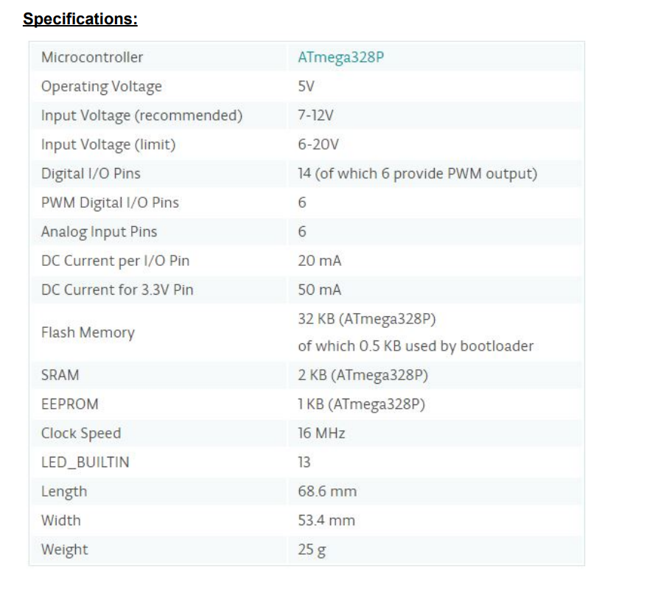

**Programming Arduino:**

**Next Install Arduino IDE**

Arduino IDE is used to program arduino. Programs are written in C++.

**B] Raspberry Pi Introduction:**

The Raspberry Pi is a series of credit card-sized single-board computers developed in the United Kingdom by the Raspberry Pi Foundation to promote the teaching of basic computer science in schools and in developing countries. It is a capable little computer which can be used in electronics projects, and for many of the things that your desktop PC does, like spreadsheets, word processing, browsing the internet, and playing games. It also plays high-definition video.

The Raspberry Pi is open hardware, with the exception of the primary chip on the Raspberry Pi, the Broadcom SoC (System on a Chip), which runs many of the main components of the board–CPU, graphics, memory, the USB controller, etc. Many of the projects made with a Raspberry Pi are open and well-documented as well and are things you can build and modify yourself.

The Raspberry Pi was designed for the Linux operating system, and many Linux distributions now have a version optimised for the Raspberry Pi.

One powerful feature of the Raspberry Pi is the row of GPIO (general purpose input/output) pins along the top edge of the board. These pins are a physical interface between the Pi and the outside world. At the simplest level, you can think of them as switches that you can turn on or off (input) or that the Pi can turn on or off (output). Of the 40 pins, 26 are GPIO pins and the others are power or ground pins (plus two ID EEPROM pins which you should not play with unless you know your stuff!)

You can program the pins to interact in amazing ways with the real world. Inputs don't have to come from a physical switch; it could be input from a sensor or a signal from another computer or device, for example. The output can also do anything, from turning on an LED to sending a signal or data to another device. If the Raspberry Pi is on a network, you can control devices that are attached to it from anywhere and those devices can send data back. Connectivity and control of physical devices over the internet is a powerful and exciting thing, and the Raspberry Pi is ideal for this.

**Raspberry Pi Board with GPIO:**

**Technical Specification:**

● Broadcom BCM2837 64bit ARMv7 Quad Core Processor powered Single Board Computer running at 1.2GHz

● 1GB RAM

● BCM43143 WiFi on board

● Bluetooth Low Energy (BLE) on board

● 40pin extended GPIO

● 4 x USB 2 ports

● 4 pole Stereo output and Composite video port

● Full size HDMI

● CSI camera port for connecting the Raspberry Pi camera

● DSI display port for connecting the Raspberry Pi touch screen display

● Micro SD port for loading your operating system and storing data

● Upgraded switched Micro USB power source (now supports up to 2.4 Amps)

● Expected to have the same form factor has the Pi 2 Model B, however the LEDs will change position.

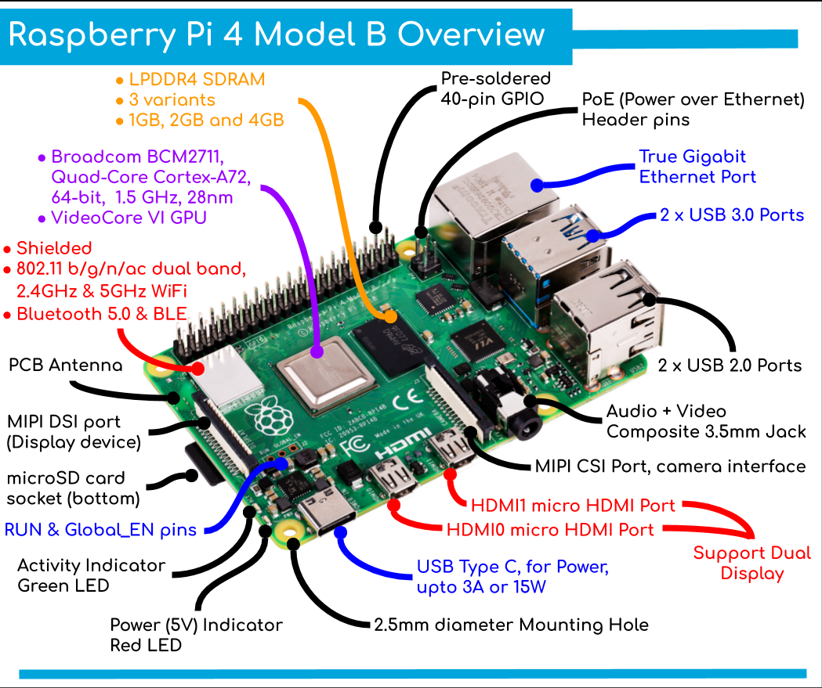

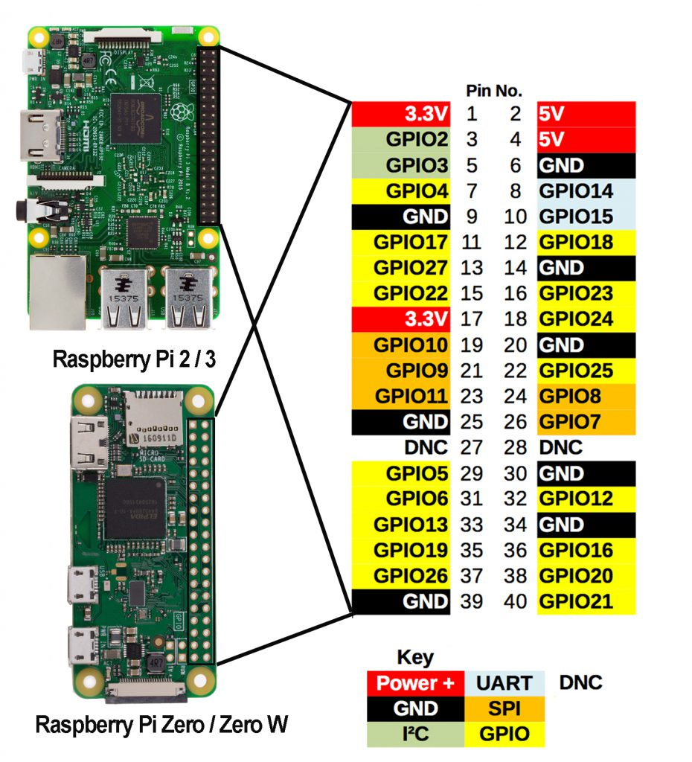

**Study installation of Raspbian OS:**

# **INSTALLATION OF RASPBIAN OS IN YOUR RASPBERRY PI**

## **Step 1: Download the Required Software and Files**

# **You need to download 2 software and 1 OS i.e. Raspbian for this complete process.**

# **1st software: The first software is Win32 Disk Imager.**

# [**https://sourceforge.net/projects/win32diskimager/**](https://sourceforge.net/projects/win32diskimager/)

# **2nd software: Second software is SD Card Formatter.**

# [**https://www.sdcard.org/downloads/formatter_4/**](https://www.sdcard.org/downloads/formatter_4/)

# **Raspbian OS: This is the Main operating system of the Pi.**

[**https://www.raspberrypi.com/software/operating-systems/**](https://www.raspberrypi.com/software/operating-systems/)

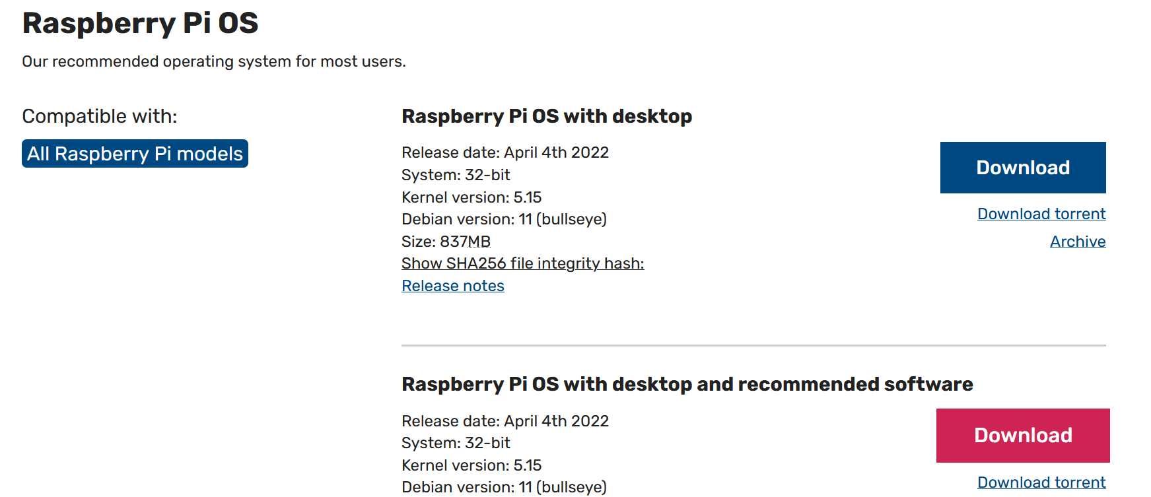

### **1 Choose Raspberry Pi OS with desktop and recommended software**

Other softwares required are

1. Rufus : to format the sd card
2. Win32imager to Boot the os
3. https://sourceforge.net/projects/win32diskimager/

**Conclusion: -**

Thus, we to Study of various development boards- Arduino Uno and Raspberry Pi, Node MCU.

DOP: / /2023 DOS: / /2023

**Experiment No: 02**

**Arduino Blink Example**

**Aim:** To get familiar with Arduino IDE by blinking LED using Arduino Uno R3.

**Hardware Components & Services Required:**

* Arduino IDE
* Arduino UNO R3
* Jumper Wire
* 1 LED
* 1 x 1kΩ Resistor
* Breadboard

**Theory:**

The Arduino Software (IDE) allows you to write programs and upload them to your board. Download the Arduino IDE from https://www.arduino.cc/en/Main/Software and install it. Following is how Arduino IDE looks like.

**Follow these steps to upload your sketch:**

1. Connect your Arduino using the USB cable. The square end of the USB cable connects to your Arduino and the flat end connects to a USB port on your computer.

2. Choose Tools→Board→Arduino Uno to find your board in the Arduino menu. You can also find all boards through this menu, such as the Arduino MEGA 2560 and Arduino Leonardo.

3. Choose the correct serial port for your board. You find a list of all the available serial ports by choosing Tools→Serial Port→ comX or /dev/tty.usbmodemXXXXX. X marks a sequentially or randomly assigned number. In Windows, if you have just connected your Arduino, the COM port will normally be the highest number, such as com 3 or com 15.Many devices can be listed on the COM port list, and if you plug in multiple Arduinos, each one will be assigned a new number. On Mac OS X, the /dev/tty.usb modem number will be randomly assigned and can vary in length, such as/dev/tty.usbmodem1421 or /dev/tty.usbmodem262471. Unless you have another Arduino connected, it should be the only one visible.

4. Click the Upload button.This is the button that points to the right in the Arduino environment. You can also

use the keyboard shortcut Ctrl+U for Windows or Cmd+U for Mac OS X.

**Note:** The verify button only compiles the code but the upload button compiles and uploads

the code on Arduino.

**LED**

LEDs (that’s “ell-ee-dees”) are a particular type of diode that convert electrical energy into light. In fact, LED stands for “Light Emitting Diode.”

The positive side of the LED is called the “anode” and is marked by having a longer “lead,”or leg. The other, negative side of the LED is called the “cathode.” Current flows from the anode to the cathode and never the

opposite direction. A reversed LED can keep an entire circuit from operating properly by blocking current flow.

**Breadboard:**

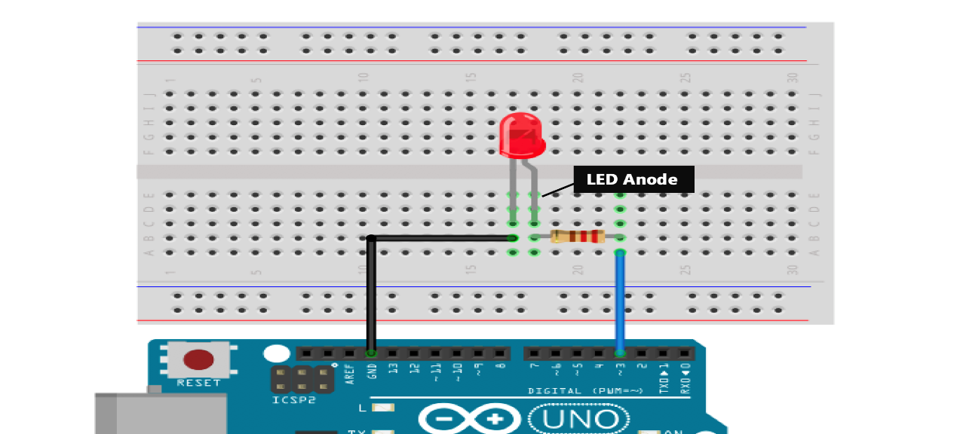

**Circuit Connection:**

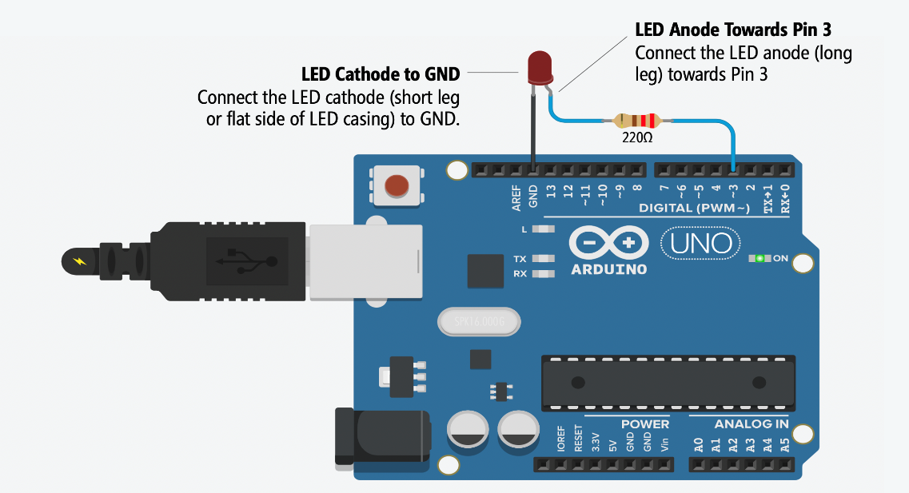

**Code:**

// the setup function runs once when you press reset or power the board

void setup() {

// initialize digital pin 13 as an output.

pinMode(13, OUTPUT);

}

// the loop function runs over and over again forever

void loop() {

digitalWrite(13, HIGH); // turn the LED on (HIGH is the voltage level)

delay(1000); // wait for a second

digitalWrite(13, LOW); // turn the LED off by making the voltage LOW

delay(1000); // wait for a second

}

**Result:**

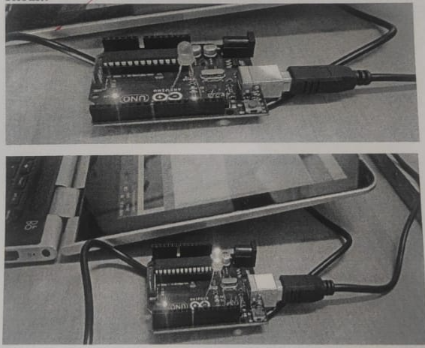

**Conclusion:**

Thus, we to get familiar with Arduino IDE by blinking LED using Arduino Uno R3.

DOP: / /2023 DOS: / / 2023

**Experiment No: 03**

**Arduino - Ultrasonic Sensor**

**Aim**: - Arduino - Ultrasonic Sensor

**Theory:**

**Ultrasonic Sensor:**

The HC-SR04 ultrasonic sensor uses SONAR to determine the distance of an object just like the bats do. It offers excellent non-contact range detection with high accuracy and stable readings in an easy-to-use package from 2 cm to 400 cm or 1” to 13 feet.

The operation is not affected by sunlight or black material, although acoustically, soft materials like cloth can be difficult to detect. It comes complete with ultrasonic transmitter and receiver module.

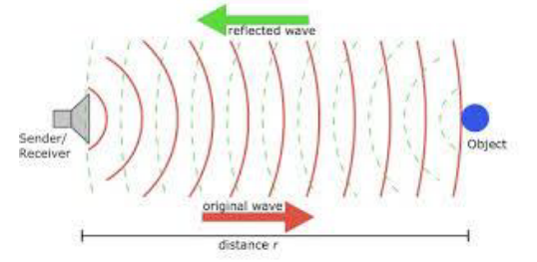

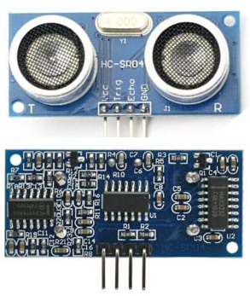

## **Technical Specifications:**

* **Power Supply − +5V DC**
* **Quiescent Current − <2mA**
* **Working Current − 15mA**
* **Effectual Angle − <15°**
* **Ranging Distance − 2cm – 400 cm/1″ – 13ft**
* **Resolution − 0.3 cm**
* **Measuring Angle − 30 degree**

## **Components Required**

**You will need the following components −**

* **1 × Breadboard**
* **1 × Arduino Uno R3**
* **1 × ULTRASONIC Sensor (HC-SR04)**

## 

## **Procedure**

**Follow the circuit diagram and make the connections as shown in the image given below.**

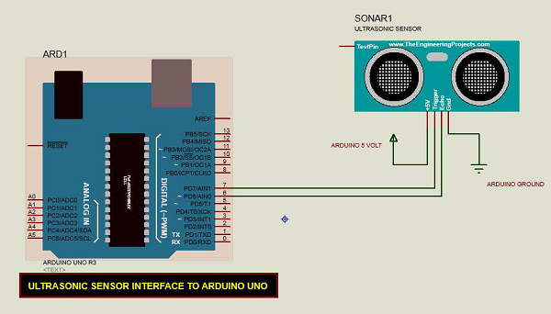

## **Sketch:**

Open the Arduino IDE software on your computer. Coding in the Arduino language will control your circuit. Open a new sketch File by clicking New.

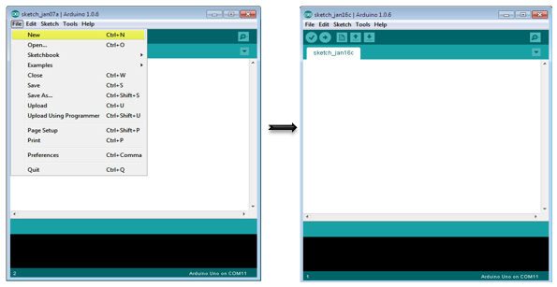

## 

## **Arduino Code:**

const int pingPin = 7; // Trigger Pin of Ultrasonic Sensor

const int echoPin = 6; // Echo Pin of Ultrasonic Sensor

void setup() {

Serial.begin(9600); // Starting Serial Terminal

}

void loop() {

long duration, inches, cm;

pinMode(pingPin, OUTPUT);

digitalWrite(pingPin, LOW);

delayMicroseconds(2);

digitalWrite(pingPin, HIGH);

delayMicroseconds(10);

digitalWrite(pingPin, LOW);

pinMode(echoPin, INPUT);

duration = pulseIn(echoPin, HIGH);

inches = microsecondsToInches(duration);

cm = microsecondsToCentimeters(duration);

Serial.print(inches);

Serial.print("in, ");

Serial.print(cm);

Serial.print("cm");

Serial.println();

delay(100);

}

long microsecondsToInches(long microseconds) {

return microseconds / 74 / 2;

}

long microsecondsToCentimeters(long microseconds) {

return microseconds / 29 / 2;

}

**Code to Note:**

The Ultrasonic sensor has four terminals - +5V, Trigger, Echo, and GND connected as follows −

* Connect the +5V pin to +5v on your Arduino board.
* Connect Trigger to digital pin 7 on your Arduino board.
* Connect Echo to digital pin 6 on your Arduino board.
* Connect GND with GND on Arduino.

In our program, we have displayed the distance measured by the sensor in inches and cm via the serial port.

**Function description:**

long microsecondsToInches(long microseconds)

{

// According to the Ping sensor datasheet, there are

// 73.746 microseconds per inch (i.e. sound travels at 1130 feet per

// second). This gives the distance travelled by the ping, outbound

// and return, so we divide by 2 to get the distance of the obstacle.

return microseconds / 74 / 2;

}

long microsecondsToCentimeters(long microseconds)

{

// The speed of sound is 340 m/s or 29 microseconds per centimeter.

// The ping travels out and back, so to find the distance of the

// object we take half of the distance travelled.

return microseconds / 29 / 2;

}

**Result:**

You will see the distance measured by sensor in inches and cm on Arduino serial monitor. And when the distance measured by the sensor is 20 cm or less, the buzzer will turn on, otherwise it will remain off.

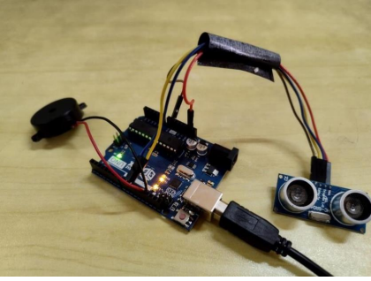

**Output:**

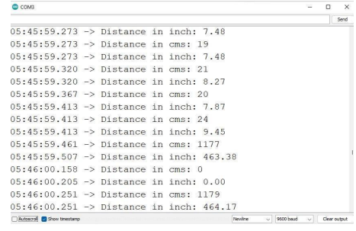

**Conclusion:**

The Arduino ultrasonic sensor is a versatile and cost-effective tool for measuring distance, proximity and obstacle detection in various applications. It operates by sending and receiving high-frequency sound waves and measuring the time delay between the transmission and reception. The sensor provides a simple interface to read the distance data, making it easy to integrate into various projects. With its small size, low power consumption, and high accuracy, the Arduino ultrasonic sensor is a popular choice for DIY projects and educational purposes.

1. Connected the VCC pin of the sensor to 5V power supply on the Arduino board.
2. Connected the GND pin of the sensor to GND on the Arduino board.
3. Connected the Trig pin of the sensor to a digital pin on the Arduino board (e.g., pin 9).
4. Connected the Echo pin of the sensor to another digital pin on the Arduino board (e.g., pin 8).
5. Connected the positive terminal of the buzzer to a digital pin on the Arduino board (e.g., pin 13).
6. Connected the negative terminal of the buzzer to GND on the Arduino board. When the distance measured by the sensor is 20 cm or less, the buzzer will turn on, otherwise it will remain off.

DOP: / /2023 DOS: / / 2023

**Experiment No: 04**

**Aim**: - Write a program for ESP8266 DHT11/DHT22 Temperature and Humidity Web Server with Arduino IDE

**Theory:**

The ESP8266 is a low-cost, Wi-Fi enabled microcontroller that can be used for a variety of applications. The DHT11 and DHT22 are two popular temperature and humidity sensors that can be interfaced with the ESP8266 to create a simple weather monitoring system.

The ESP8266 is a low-cost Wi-Fi microchip with full TCP/IP stack capability. It can be programmed using the Arduino IDE and is a popular choice for Internet of Things (IoT) projects due to its affordability and ease of use. The DHT11 and DHT22 are two popular types of temperature and humidity sensors that can be used with the ESP8266.

The DHT11 sensor is a basic, low-cost digital temperature and humidity sensor. It can measure temperatures from 0 to 50 degrees Celsius with an accuracy of ±2 degrees Celsius, and relative humidity from 20% to 90% with an accuracy of ±5%. The DHT22 sensor, also known as the AM2302, is a more advanced version of the DHT11. It can measure temperatures from -40 to 80 degrees Celsius with an accuracy of ±0.5 degrees Celsius, and relative humidity from 0% to 100% with an accuracy of ±2%. Both sensors use a single-wire serial interface to communicate with the ESP8266.

To use the DHT11 or DHT22 with the ESP8266, you will need to connect the sensor to the microcontroller using a pull-up resistor and a voltage divider. The pull-up resistor is used to ensure that the data line remains high when it is not being used, while the voltage divider is used to reduce the voltage level of the data line to a level that can be read by the ESP8266.

Once the sensor is connected to the ESP8266, you can use a library such as the Adafruit DHT library to read temperature and humidity values from the sensor. The library communicates with the sensor using the single-wire serial interface and provides a simple API for reading temperature and humidity values.

It is important to note that the DHT11 and DHT22 sensors are sensitive to timing and can be affected by environmental factors such as temperature and humidity. It is recommended to take multiple readings and average the values to improve the accuracy of the sensor readings. Additionally, the DHT11 and DHT22 sensors are not recommended for applications where high accuracy is required, as they have a limited measurement range and accuracy compared to more advanced sensors.

**• Steps for reading sensor data.**

Step 1: To begin reading sensor data, you will need to install the DHT sensor library. It is available from the Arduino library manager.

To install the library, navigate to Sketch > Include Library > Manage Libraries… Wait for the Library Manager to download the libraries index and update the list of installed libraries.

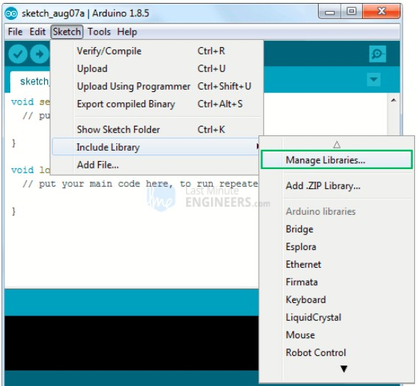

Filter your search by entering ‘DHT sensor’. Look for the DHT sensor library by Adafruit. Click on that entry and then choose Install.

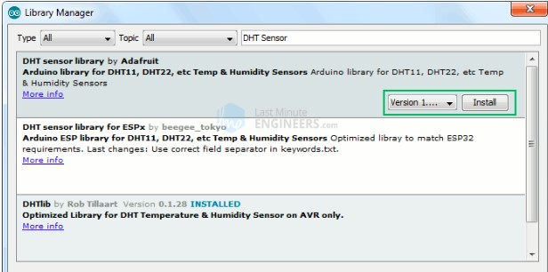

The DHT sensor library makes use of the Adafruit Sensor support backend. So, look for Adafruit Unified Sensor in the library manager and install it as well.

**▪ Creating an ESP8266 Web Server using WiFi Station (STA) mode :**

As the title implies, we will configure an ESP8266 web server in Station (STA) mode to serve web pages to any connected client on the existing network.

Before you begin uploading the sketch, you must replace the following two variables with your network credentials so that the ESP8266 can connect to an existing network.

## **INPUT:**

#include <ESP8266WiFi.h>

#include <ESP8266WebServer.h>

#include "DHT.h"

// Uncomment one of the lines below for whatever DHT sensor type you're using!

//#define DHTTYPE DHT11 // DHT 11

//#define DHTTYPE DHT21 // DHT 21 (AM2301)

#define DHTTYPE DHT22 // DHT 22 (AM2302), AM2321

/*Put your SSID & Password*/ const char* ssid = "YourNetworkName"; // Enter SSID here const char* password = "YourPassword"; //Enter Password here ESP8266WebServer server(80);

// DHT Sensor uint8_t DHTPin = D8;

// Initialize DHT sensor.

DHT dht(DHTPin, DHTTYPE);

float Temperature;

float Humidity;

void setup() { Serial.begin(115200); delay(100);

pinMode(DHTPin, INPUT);

dht.begin();

Serial.println("Connecting to ");

Serial.println(ssid);

//connect to your local wi-fi network

WiFi.begin(ssid, password);

//check wi-fi is connected to wi-fi network while (WiFi.status() != WL_CONNECTED) {

delay(1000);

Serial.print(".");

}

Serial.println("");

Serial.println("WiFi connected..!");

Serial.print("Got IP: "); Serial.println(WiFi.localIP());

server.on("/", handle_OnConnect); server.onNotFound(handle_NotFound);

server.begin();

Serial.println("HTTP server started");

}

void loop() {

server.handleClient();

}

void handle_OnConnect() {

Temperature = dht.readTemperature(); // Gets the values of the temperature Humidity = dht.readHumidity(); // Gets the values of the humidity server.send(200, "text/html", SendHTML(Temperature,Humidity)); }

void handle_NotFound(){

server.send(404, "text/plain", "Not found");

}

String SendHTML(float Temperaturestat,float Humiditystat){

String ptr = "<!DOCTYPE html> <html>\n";

ptr +="<head><meta name=\"viewport\" content=\"width=device-width, initialscale=1.0, user-scalable=no\">\n";

ptr +="<title>ESP8266 Weather Report</title>\n";

ptr +="<style>html { font-family: Helvetica; display: inline-block; margin: 0px auto; text-align: center;}\n";

ptr +="body{margin-top: 50px;} h1 {color: #444444;margin: 50px auto

30px;}\n";

ptr +="p {font-size: 24px;color: #444444;margin-bottom: 10px;}\n"; ptr +="</style>\n"; ptr +="</head>\n"; ptr +="<body>\n";

ptr +="<div id=\"webpage\">\n";

ptr +="<h1>ESP8266 NodeMCU Weather Report</h1>\n";

ptr +="<p>Temperature: "; ptr +=(int)Temperaturestat; ptr +="°C</p>"; ptr +="<p>Humidity: "; ptr +=(int)Humiditystat;

ptr +="%</p>";

ptr +="</div>\n"; ptr +="</body>\n"; ptr +="</html>\n";

return ptr;

}

**Accessing the Web Server**:

After uploading the sketch, open the Serial Monitor at 115200 baud and press the RESET button on the Node MCU. If everything is fine, it will display the dynamic IP address obtained from your router as well as the “HTTP server started” message.

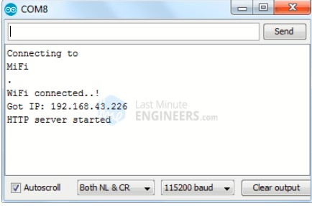

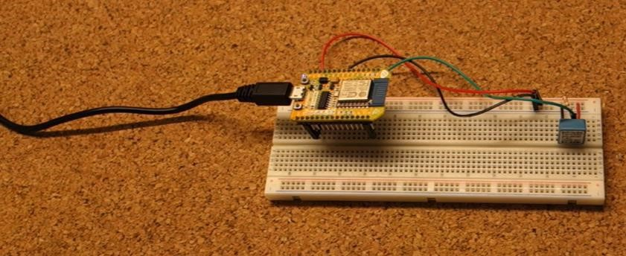

Next, launch a browser and navigate to the IP address displayed on the serial monitor. The ESP8266 should serve a web page with the current temperature and relative humidity.

**Result**:-

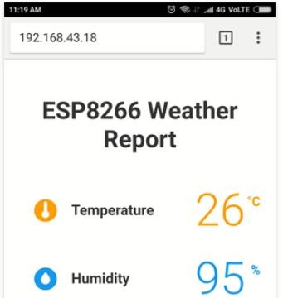

**Conclusion:**

Thus, we were able to write a program for ESP8266 DHT11/DHT22 Temperature and Humidity Web Server with Arduino IDE. It is important to note that the DHT11 and DHT22 sensors are sensitive to timing and can be affected by environmental factors such as temperature and humidity

DOP: / /2023 DOS: / / 2023

**Experiment No: 05**

**Aim**: - To install Contiki OS and study cooja simulator working with hello world example.

**Theory:**

**Contiki:**

Contiki OS is an open-source operating system designed for resource- constrained embedded devices and IoT (Internet of Things) applications. It was first released in 2003 by Adam Dunkel’s, and has since become a popular choice for developers looking to create applications for a wide range of low- power wireless devices. One of the key features of Contiki OS is its support for multiple network protocols, including IPv6, 6LoWPAN, RPL, CoAP, and MQTT. This makes it possible to create IoT applications that can communicate with a variety of different devices and services. Contiki OS also includes a range of built-in libraries and tools, such as a lightweight TCP/IP stack, a web server, and support for various wireless sensor networks.

**Cooja simulator:**

COOJA (Cooja Simulator for Wireless Sensor Networks) is a network simulator that is commonly used for developing and testing wireless sensor network (WSN) applications. It is typically used in conjunction with the Contiki OS, which is an operating system designed for low-power IoT devices.

**Installation Steps:**

**Step 1:** Simply follow this link to download Instant Contiki.

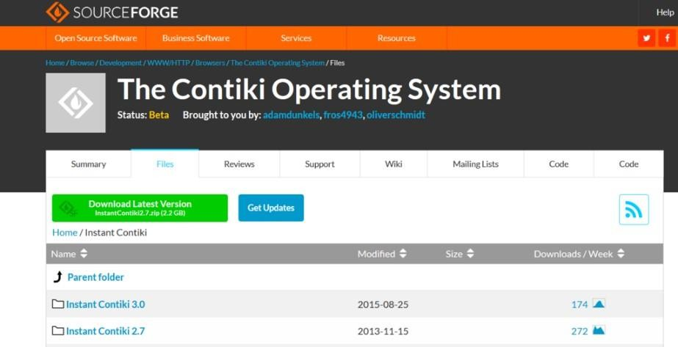

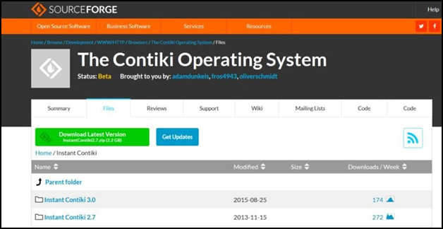

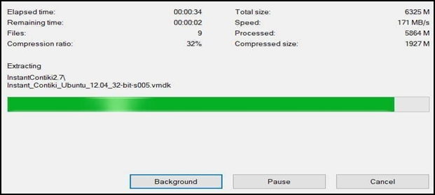 **Step 2**: unzip the download file.

**Step 3:** Start your virtualization software like Vmware or Virtualbox and load your Instant Contiki File. In Vmware click Open a Virtual Machine as shown below.

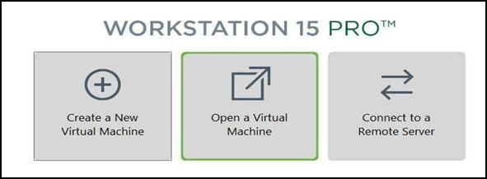

**Step 4**: Navigate to the extracted folder .vmx file.

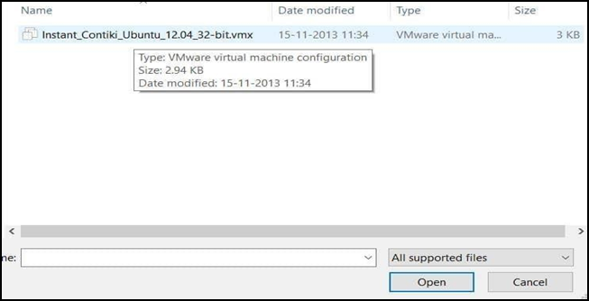

**Step 5**: Power on your machine

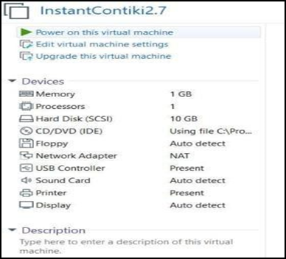

**Step 6**: Select “I copied it” option

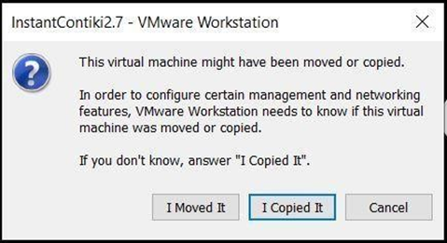

**Step 7:** Enter your credentials and start using Instant Contiki (Username and Password is user).

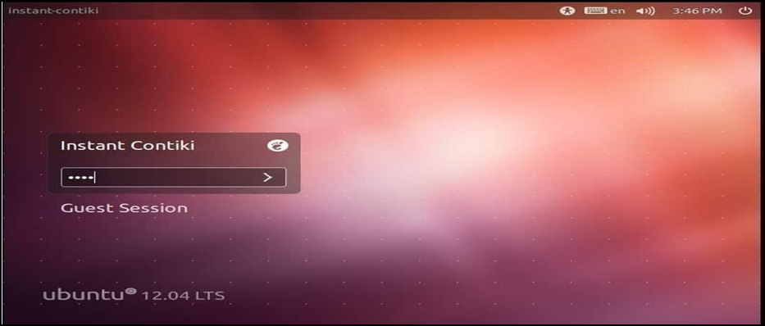

**Input**:

Opening up Contiki by entering the password

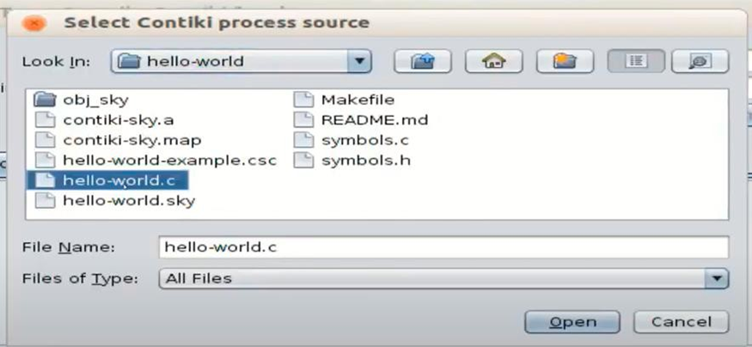

Choosing the helloworld.C file to execute our program in Contiki.

